Functional design  
ISGPKBS

**Group 3**  
Wendy Neijenhuis  
Janita Veenstra  
Dominik Lewy   
Erik Peters  
Job van der Toom

Contents

Requirements 3

Screen designs 5

Levels 5

Level 1; Beach 5

Level 2; Forest 6

level 3; Southpole 7

Splashscreens 8

Intro 8

Level 1; Beach 8

Level 2; Forest 8

Level 3; Southpole 8

# Requirements

In the next part of the functional design we appoint every requirement and give it a priority.

|  |  |
| --- | --- |
| Priority | Requirement |
| must | Bug list |
| must | Each level has a specific theme |
| must | Each level is at least 3 screen-widths long and the height is minimal one screen-height |
| must | Enemies can move around in the playfield |
| must | Falling of the main character/enemy should be natural i.e. the character/enemy falls when there is no supporting structure of any kind at his position |
| must | In each level there will be several gadgets that make up the game play |
| must | State diagrams |
| must | Test tables |
| must | The characters in the game should have AI behaviours. |
| must | The game consists of at least 3 levels that make up the game world |
| must | The game program should make intensive use of a state machine pattern. |
| must | The game world is based on small bitmaps (tiles) that are put together through a so called: “level-map” |
| must | The main character and the enemies must have environment awareness i.e. they can bump on to walls or other constructions of the game world (boundary detection) |
| must | The main character in the game should have the following degrees of freedom: walking left, walking right and jumping |
| must | The movement of the main character is handled by the arrow keys of the keyboard. |
| must | There will be minimal two background layers to demonstrate parallax scrolling |
| must | UML class diagram |
| must | When a player collides with a gadget, action should be taken (getting points, die, getting extra lives or changing the world map) |
| must | When the game starts/ends there must be a splash screen |
| must | When the main character runs out of lives the game should end |
| should | The main character can throw gadgets |
| should | At each stage of the game the player should be able to jump to a menu screen where he can save that game and see the high-scores or resume playing |
| should | Automated install |
| should | Bitmaps of the game world can be animated |
| should | Gadgets can be a variety of elements in the game: energy points, enemies, trap-doors, water, puzzles etc. Creative use of these gadgets should make the game appealing to play!! |
| should | The character should always face the direction it is walking or jumping |
| should | The game should have sound effects for several features in the game (third party product) |
| should | The game should start with this menu after the splash screen |
| should | The main character should always be in the centre of the screen during game play except when entering a level or leaving a level (player always enters a level from the left side) |
| should | The range of the enemy should be adjustable |
| should | When a player collides with a gadget (collision detection), that gadget should disappear (except enemies) |
| should | The main character has different views with each theme |
| could | Each layer is separated by a splash screen reflecting the upcoming theme |
| could | Gadgets can (must?) be animated |
| could | Most constants in het game program are parameters in a configuration file (something like params.xml). |
| could | You can define a level map using XML instead of predefined arrays in your code. |
| could | The main character can glide down from a hill |
| could | The main character can fly with balloons |

# Screen designs

## Levels

### Level 1; Beach

This is the design of the first of the three levels. This level has as theme ‘beach.

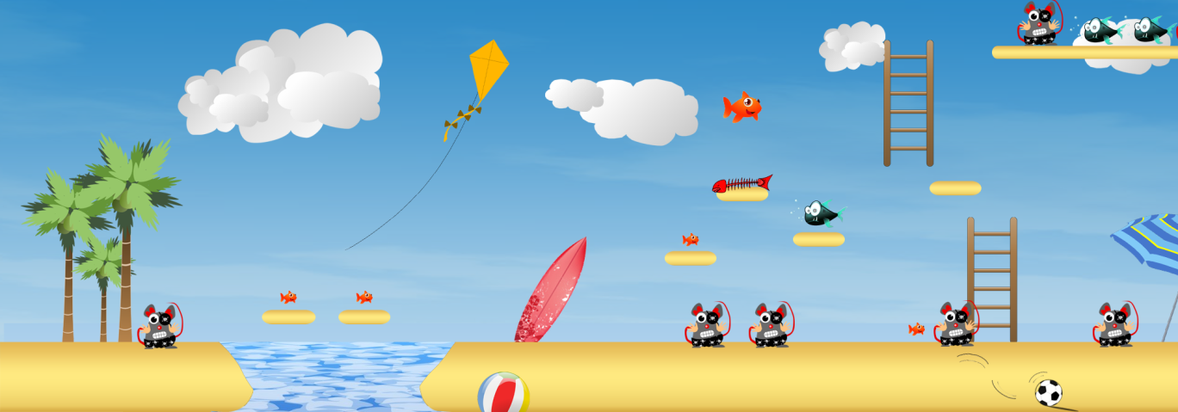

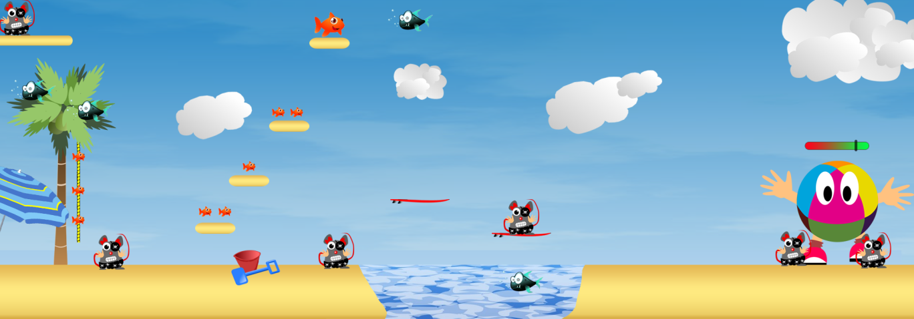

### Level 2; Forest

### level 3; Southpole

## Splashscreens

Here are our splashscreens.

### Intro



### Level 1; Beach

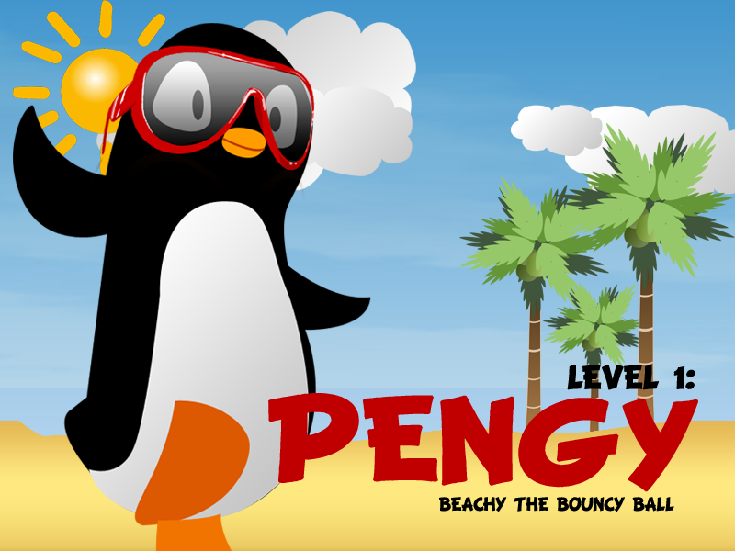

### Level 2; Forest

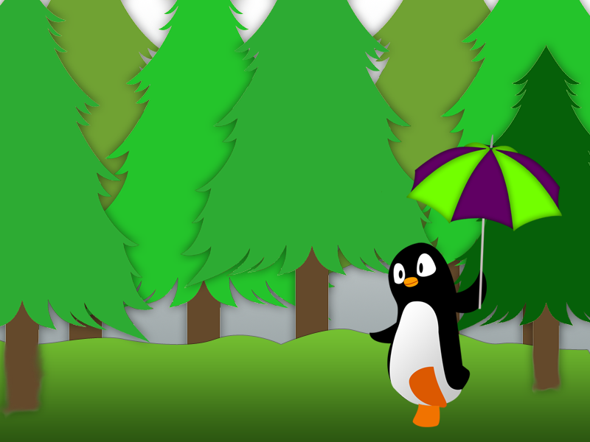

### Level 3; Southpole

